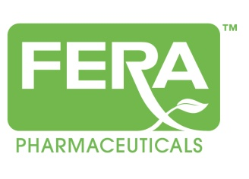

Fera Pharmaceuticals, LLC Divests Ophthalmic Product Portfolio to Perrigo Company
NEW YORK-June 17, 2013-Fera Pharmaceuticals today announced that it has signed a definitive agreement to divest and has completed the divestiture of an ophthalmic sterile ointment and solution product portfolio to Perrigo Company (NYSE: PRGO; TASE). The acquired portfolio, including nine prescription ANDA products, generated more than $30 million in net revenues during calendar year 2012.
Fera Pharmaceuticals is a privately held company. The company goal is to realize opportunities via acquisitions, in-licensing, developing and marketing abbreviated new drug applications (ANDAs), new drug applications (NDAs) and 505(b)(2) NDA products. For more information visit www.ferapharma.com.

Contact:
Susan McDougal
516-277-1450
contact@ferapharma.com

